ashutosh kesharwani

business modelling and Analysis   
 fin6003

Table of Contents

1. Introduction 3

2. Analysis 3

I. Technology: 3

Stock1 NXT.AX 3

Line chart 3

Frequency table 4

Statistics: 4

Stock2 IRE.AX 5

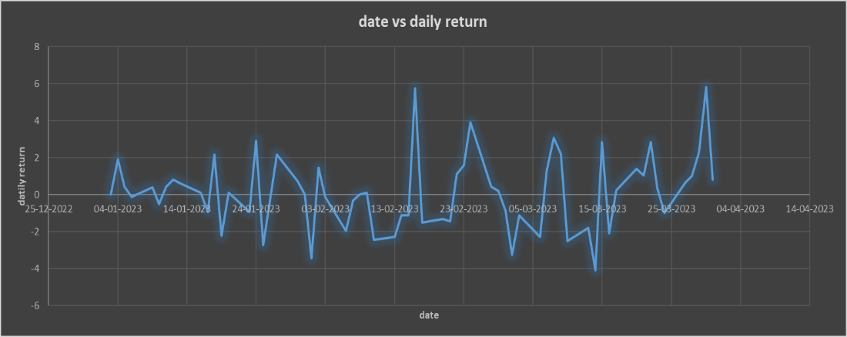 5

Descriptive Statics: 5

Frequency Table: 5

II. Industrialists 5

Stock1 TCL.AX 5

Line chart: 5

Descriptive Statics: 6

Frequency Table: 6

Stock2 QUB.AX 6

Line chart 6

Descriptive Statics: 7

Frequency table: 7

III. CONFIDENCE INTERVAL 7

1. Technology 7

2. Industrialists 7

IV. Hypothesis testing 7

Hypothesis testing 1: 7

Hypothesis Testing 2: 8

Hypothesis Testing 3: 8

3. Regression 8

4. Conclusion: 10

5. Limitations: 10

6. Ethical Implications: 10

Appendix 11

# Executive Summary

Our comprehensive analysis of daily stock returns across industries and individual stocks has unveiled key insights: Industry 1 (Technology) consistently outperformed Industry 2 (Industrialist) in average daily returns, suggesting potential investment advantages in the technology sector. Furthermore, Stock 1 in Industry 1 (Next Dc) demonstrated significantly higher daily returns compared to Stock 1 in Industry 2 (Transurban), highlighting the potential for specific tech stocks to offer superior returns. However, our linear regression analysis found a weak positive correlation between Stock 1 and Stock 2 in Industry 2, lacking statistical significance, emphasizing the need for cautious analysis before making investment decisions. While these findings provide valuable financial insights, it's essential to consider the limitations, such as data quality, scope, and sample size. Additionally, ethical principles were adhered to in conducting the analysis to ensure transparency and trust in our results.

# Introduction

This report offers a comprehensive analysis of four leading Australian companies representing diverse sectors of the economy: Qube Holdings (Qube), Transurban Group (Transurban), and the technology giants, NextDC Limited (NextDC) and Iress Limited (Iress).Qube specializes in providing logistics solutions, Transurban focuses on the development of road infrastructure, NextDC operates in the data center and technology sector, and Iress is known for its financial software solutions.

The main objective of this report is to conduct statistical analyses on the daily returns of stocks from these four companies, all of which are listed on the Australian Securities Exchange (ASX). The data encompasses the period from January 1, 2023, to March 31, 2023. This analysis employs various statistical techniques, including descriptive statistics, confidence intervals, hypothesis testing, and regression analysis, to offer valuable insights into the financial performance.

In this introduction, we provide an overview of the report's structure and methodology. We delve into the significance of our analysis, explain the data sources used to derive our conclusions, and articulate the importance of Qube, Transurban, NextDC, and Iress within their respective industries. The report aims to provide meaningful insights that can guide investment decisions and strategic planning within the logistics, infrastructure, and technology sectors.

The data utilized for this analysis was obtained from the Yahoo Finance website. It consists of the daily adjusted closing prices of the selected stocks. By applying quantitative and graphical techniques, our report showcases valuable insights that can help in assessing investment opportunities and market trends.

# Descriptive Analysis

Power BI Dashboard

NXT AX

Sum Of Volume By Month Pie chart

* The plot shows variation of volume with the months

**Description:** This chart provides a visual representation of the trading volume grouped by month. The size and color of each segment represent the volume of trades in that month. For example, January has the highest volume, followed by February, and then March. The percentages next to each month indicate theproportion of that month's volume relative to the total volume of all displayed months.

Sum OF volume By day

* The plot (bar chart) shows variation in volume with the day

**Description:** Displays the total trading volume of the stock for each day of the month. The x-axis represents the days of the month, and the y-axis indicates the volume. Bars' height gives a visual comparison of the volume of trades across different days, allowing for easy spotting of high trading activity days.

Sum of High by day

* The plot (line chart) shows variation of day’s high

**Description**: This chart plots the highest trading price for each day of the month. The x-axis shows the days, and the y-axis displays the high price. The continuous line helps identify trends or patterns in the stock's highest trading prices across the month. For instance, one can spot price peaks and valleys easily.

Sum of Low by day

* The plot (line chart) shows variation of day’s Low

**Description:** Similar in layout to the "Sum of High by Day" chart, this visual shows the lowest trading price for each day of the month. Observing this chart can provide insights into the stock's stability and potential dips in price.

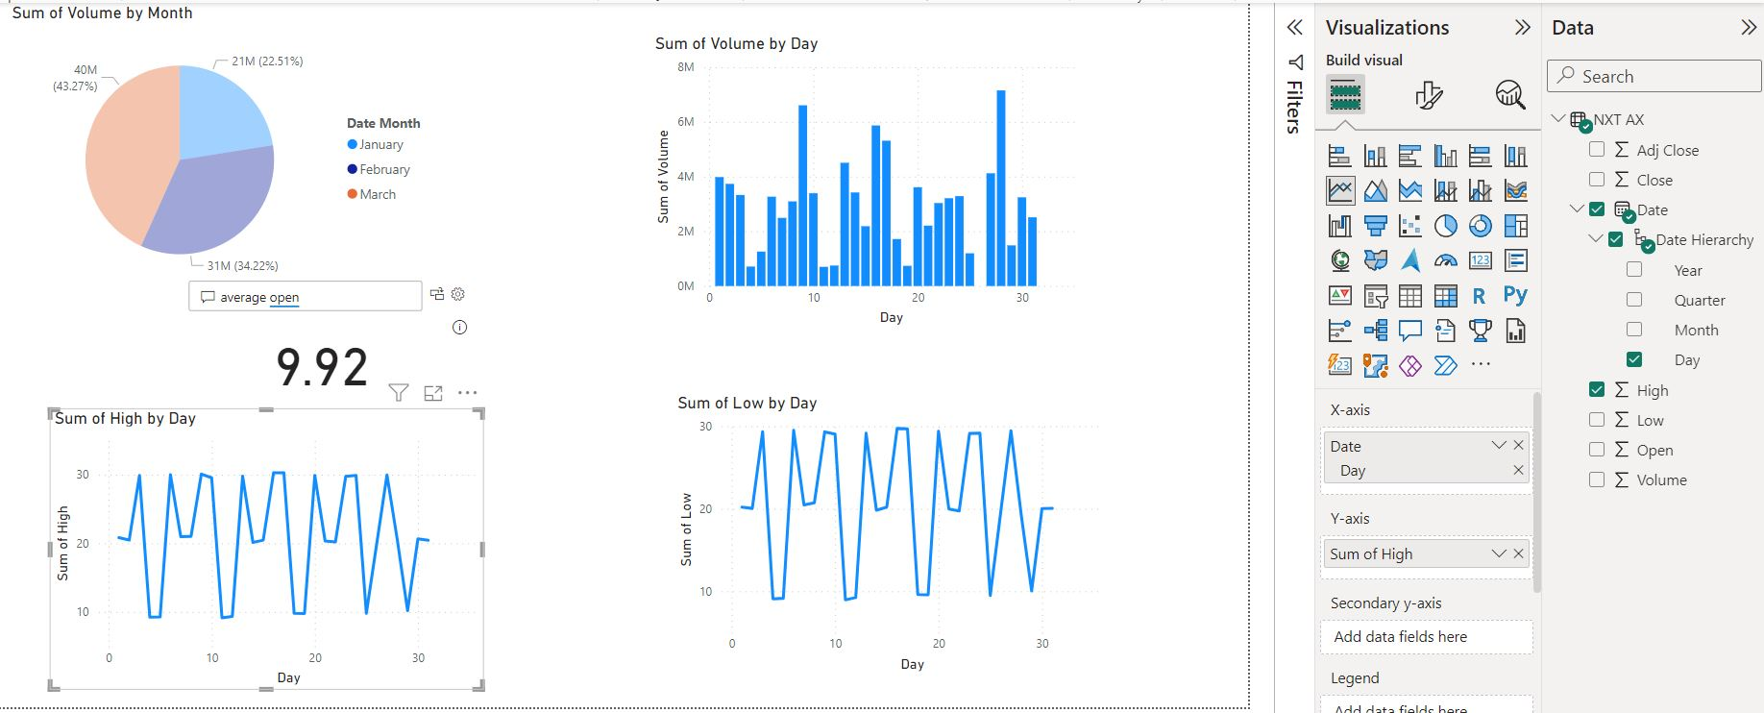

IRE AX

Sum of Volume and Sum of Volume

* Comparing volume of two different stocks (NXT AX VS IRE AX)

**Description:** This chart showcases the distribution of the trading volume over three months: January, February, and March. Each segment's size represents the volume of trades for that month. For instance, January has the largest volume, constituting 43.27% of the total volume, followed by February with 32.24% and then March with 24.25%.

Sum OF volume By day

* The plot (bar chart) shows variation in volume with the day

**Description:** This visual illustrates the total trading volume of the stock for each day of the month. The x-axis represents the days, while the y-axis shows the trading volume. The height of each bar provides a quick glance into the days with higher trading activity.

Sum of High by day

* The plot (line chart) shows variation of day’s high

**Description**: This chart represents the highest trading price of the stock for each day of the month. The x-axis displays the days, and the y-axis highlights the highest stock price for that day. The progression of the line allows for an understanding of the stock's price trends, making it easier to spot the days when the stock hit its peak prices.

Sum of Low by day

* The plot (line chart) shows variation of day’s Low.

**Description:** Analogous to the "Sum of High by Day" chart, this visual presents the lowest trading price of the stock for each day of the month. Observing this chart can provide insights into the stock's lowest trading values, enabling users to gauge its price stability and determine potential buying opportunities.

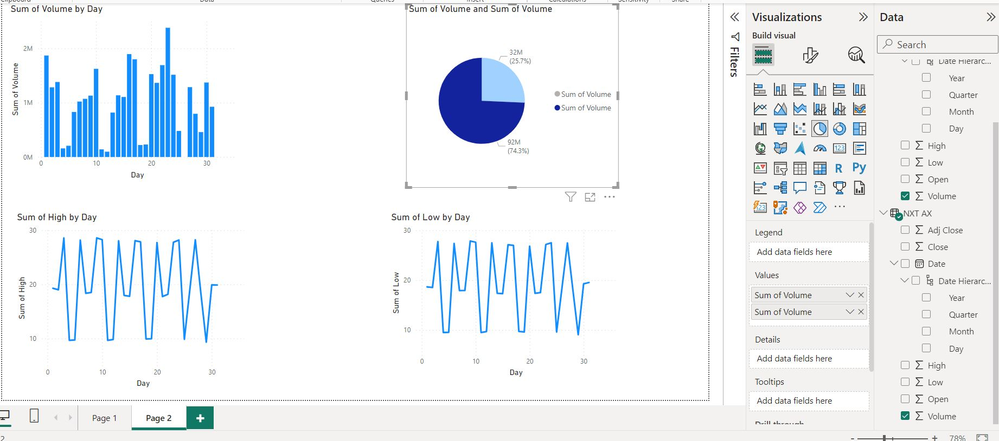

QUB AX

Sum Of Adj Close By Month Pie chart

* The plot shows variation of volume with the months.

**Description:** This chart depicts the adjusted closing price's distribution over three months: January, February, and March. Each segment's size reflects the adjusted close value for that particular month. From the visual, January holds the most significant adjusted close, contributing 37.4% to the total, followed by February at 24.23% and March at 38.5%. This information can hint at monthly performance and stability in terms of closing prices.

Sum OF volume By day

* The plot (bar chart) shows variation in volume with the day.

**Description:** This chart illustrates the total trading volume of the stock for each day of the month. The x-axis represents the days of the month, while the y-axis showcases the trading volume. By observing the height of the bars, one can identify the days with the highest trading activity. There seems to be a noticeable increase in trading volume around the middle of the month, indicating increased trading activity or interest during that time.

Sum of High by day

* The plot (line chart) shows variation of day’s high

**Description:** This chart displays the highest trading price of the stock for each day of the month. With days on the x-axis and the high stock price on the y-axis, this line graph provides insights into the stock's peak prices. Observing the line's fluctuations, one can deduce the stock's volatility and the days on which it reached its maximum prices.

Sum of Low by day

* The plot (line chart) shows variation of day’s Low

**Description:** This visual, similar in structure to the "Sum of High by Day" chart, portrays the lowest trading price of the stock for each day. By studying this graph, users can gauge the stock's price stability and identify potential buying opportunities, especially on days when the stock hit its lowest prices.

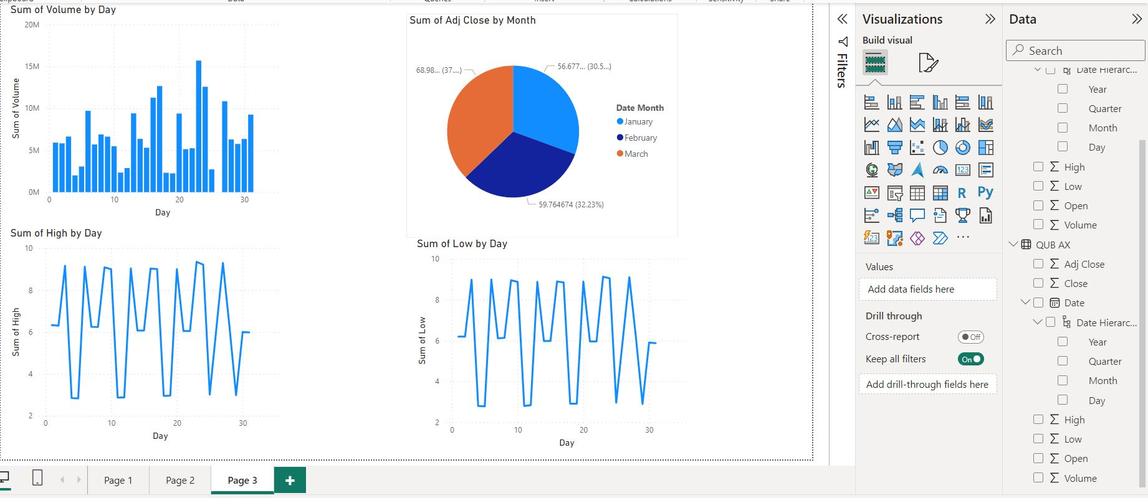

TCL AX

Sum Of Adj Close By Month Pie chart

* The plot shows variation of volume with the months.

**Description**: At a glance, this pie chart appears to compare two volume metrics. However, upon closer inspection, both represent the 'Sum of Volume' but have different values. The blue segment indicates a volume of 202M (68.31%), and the dark blue segment indicates a volume of 93.5M (31.69%). The purpose or distinction between these two metrics isn't clear from the chart alone, but they could represent volumes from different sources or timeframes.

Sum OF volume By day

* The plot (bar chart) shows variation in volume with the day.

**Description:** This chart presents the total trading volume for each day of the month. The x-axis signifies the days, and the y-axis depicts the trading volume. The bars' height reveals days with significant trading activities. The trading volume seems to be sporadic with a notable increase in activity around the 10th and 20th days of the month.

Sum of High by day

* The plot (line chart) shows variation of day’s high

**Description:** This graph showcases the highest trading price each day of the month. With the days plotted on the x-axis and the high stock price on the y-axis, one can observe the stock's peak prices. The line's undulation provides insights into the stock's volatility over the month.

Sum of Low by day

* The plot (line chart) shows variation of day’s Low.

**Description:** This chart, resembling the "Sum of High by Day" visual, details the lowest trading price each day. It's a mirror to the high prices and can be studied to understand the stock's lowest trading levels and any potential buying opportunities.

Sum of Volume and Sum of Volume

sComparing volume of two different stocks(QUB AX VS TCL AX)

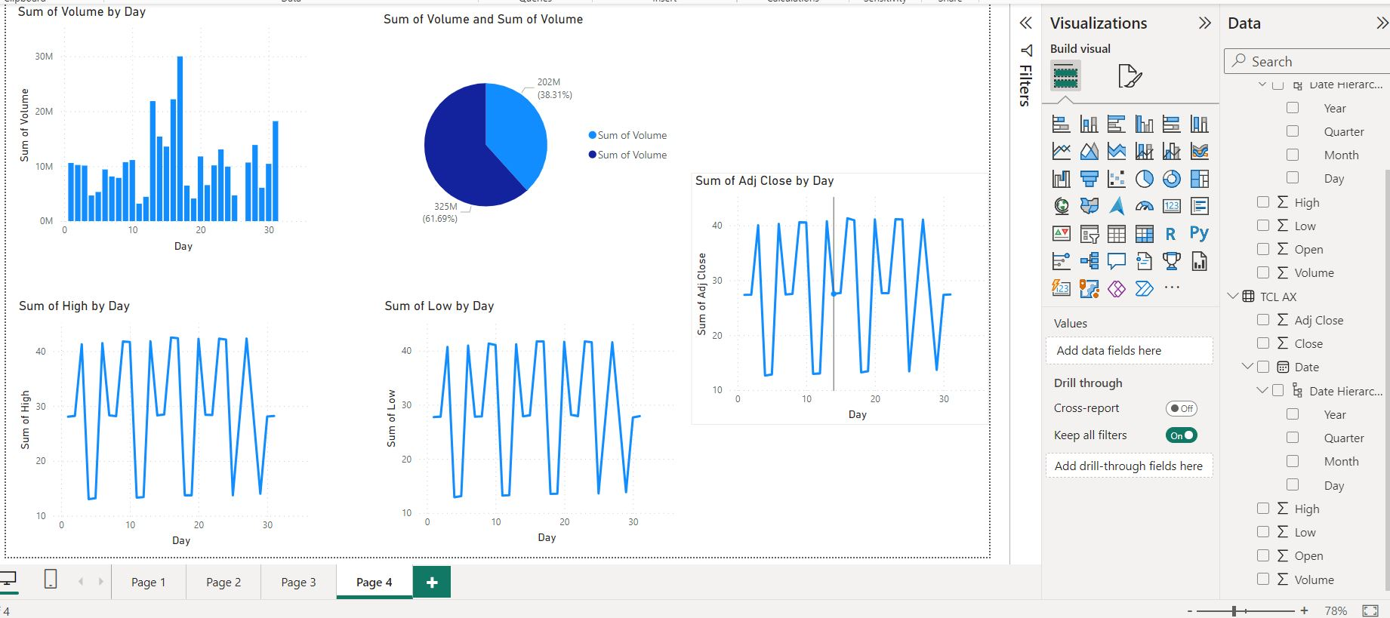

We employed **Adj Close** data from each stock and computed daily returns using the formula:

Return on ***day i = 100 * (Adj Close on day i - Adj Close on day i-1) / Adj Close on day i-1***

## Technology:

### Stock1 NXT.AX

### Line chart

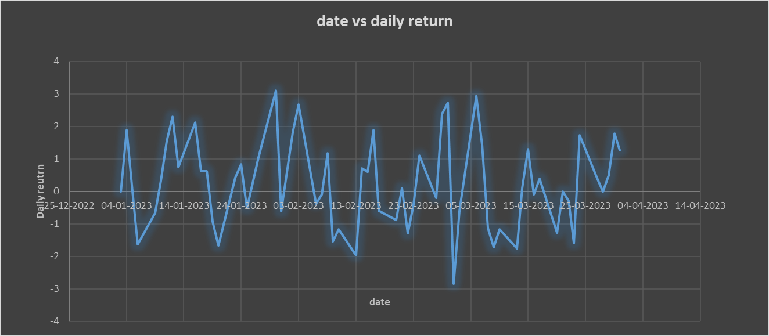

Figure 1 The line chart graph between the daily return and date of NXT.AX

The data seems exhibit fluctuations over time. Values vary from positive to negative, indicating a degree variability in the dataset. There is a period of generally increasing values from around 07-02-2023 to 28-02-2023. There are occasional spikes in the data, where values significantly deviate from the mean. For example, on 30-01-2023 and 01-03-2023, there are relatively high positive values. Some periods exhibit relatively consistent values close to zero, indicating periods of stability or low volatility. (Yahoo finance, 2023)

**Overall, there are more negative values than positive values in the dataset, suggesting a general downward trend or bias.**

### Frequency table

In table 1, the largest frequency of occurrences falls within the interval of -1% to 1%, which suggests that most days have relatively small changes in the metric, close to zero. There are more occurrences in the negative return intervals (-3% to -1%) compared to the positive return intervals (1% to 3%). There are fewer occurrences of extreme returns (greater than 3% in either direction).

## Statistics:

In Table 2, The mean value of approximately 0.25 indicates the average daily return. With a standard deviation of approximately 1.40, this parameter measures the dispersion of daily returns. The range of approximately 5.95 represents the spread between the minimum and maximum daily returns. (Khandelwal, 2021)

## Stock2 IRE.AX

## 

Figure 2 The line chart graph between the daily return and date of IRE.AX

Daily values fluctuate from positive to negative. A distinct trend emerges, with a generally increasing pattern from approximately 07-02-2023 to 28-02-2023, suggesting a period of heightened market. The graph showcases occasional spikes, with values s deviating from the mean, as evident on 30-01-2023 and 01-03-2023.Some intervals exhibit a relatively stable pattern, with values hovering close to zero. (Yahoo finance, 2023)

## Descriptive Statics:

In Table 3, the mean value, approximately 0.16, signifies the average value of the observations. The standard deviation, approximately 2.02, indicates the extent of. The range, around 9.89, illustrates the span between the minimum and maximum daily returns. (Khandelwal, 2021)

## Frequency Table:

In Table 4, there is a negative bias, particularly in the -1% to -3% range. However, there is also variability, with positive returns spanning multiple intervals. Notably, extreme positive returns exceeding 4% are absent from the dataset.

## Industrialists

### Stock1 TCL.AX

### Line chart:

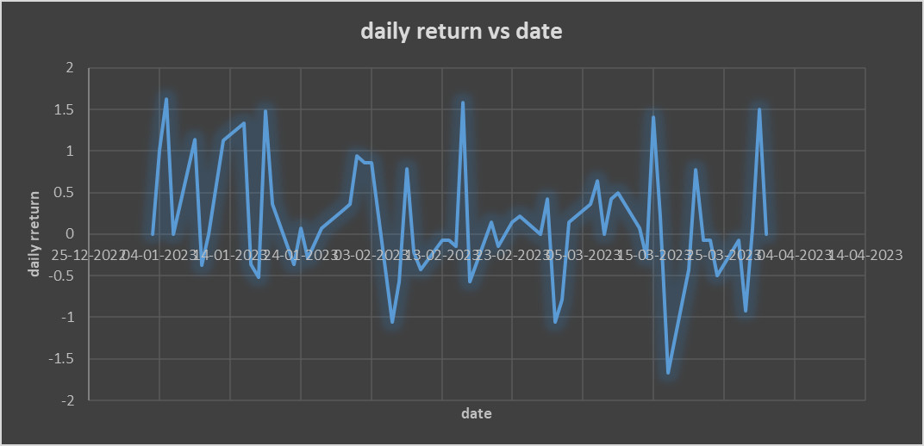

Figure 3 The line chart graph between the daily return and date of TCL.AX

The data showcases fluctuations over time, with daily values oscillating between positive and negative values. There is a distinct period of steadily increasing values, around 07-02-2023 and 28-02-2023, suggesting a s positive trend. Within the dataset are occasional spikes, representing instances where values significantly deviate from the mean. For instance, on 30-01-2023 and 01-03-2023, the data records relatively high positive values. (Yahoo finance, 2023)

### Descriptive Statics:

In Table 5, The mean value of approximately 0.167 indicates the average of the dataset, providing a central measure for the values of the dataset. With a standard deviation of approximately 0.689, this talks about the dispersion within the dataset, indicating diversion in the values from mean. The range, around 3.288, explains the span between the minimum and maximum values in the dataset. (Khandelwal, 2021)

### Frequency Table:

In Table 6, There are no occurrences in the -3% to -2% and 2% to 3% intervals, indicating the absence of extreme daily movements during the observed period. The most frequent daily returns fall within the -1% to 0% and 0% to 1% intervals, suggesting that a significant portion of the dataset consists of relatively small daily changes.

## Stock2 QUB.AX

### Line chart

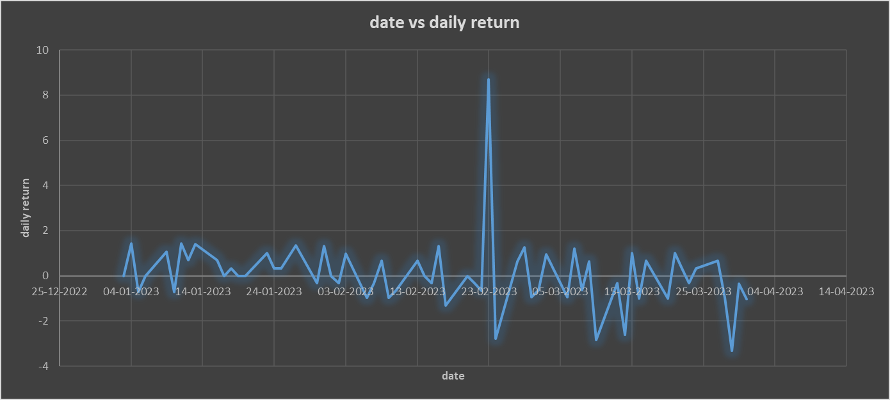

Figure 4 The line chart graph between the daily return and date of QUB.AX

An initial period of relatively stable returns in early January. A significant positive trend starting around mid-January, characterized by consistently positive returns. A period of high volatility and alternating positive and negative returns in early February. Subsequent fluctuations with some positive spikes and dips. A sharp positive spike on 30-01-2023 and 01-03-2023.

A significant negative spike on 02-03-2023. (Yahoo finance, 2023)

### 

### Descriptive Statics:

In Table 7,On average, there is a positive daily return, indicating overall positive performance during the period. The moderate standard deviation implies some level of variability. The negative kurtosis suggests a distribution slightly less peaked than normal, while positive skewness indicates a slight rightward skew in the distribution. (Khandelwal, 2021)

### 

### Frequency table:

In Table 8, the majority of daily returns fall within the -1% to 1% range, with 21 occurrences in the 0% to 1% interval and 22 occurrences in the -1% to 0% interval. While smaller changes dominate, the data also includes occurrences in the -2% to -1% and 1% to 2% intervals, indicating a degree of variability in the daily returns.

## CONFIDENCE INTERVAL

### Technology Industry

We are 95% confident that the true population parameter average daily return i.e. mean for the dataset, which includes Next Dc limited with a mean value of approximately 0.2521 and Iress limited with a mean value of approximately 0.1589, lies within the calculated confidence interval. The analysis is based on the sample data provided in the appendix in Table 9.

### Industrialists Industry

We are 95% confident that the true population parameter (e.g., mean) for the dataset, which includes Qube Holdings (Qube) with a mean value of approximately 0.1671 and Transurban Group (Transurban) with a mean value of approximately 0.0808, lies within the calculated confidence interval. The analysis is based on the sample data provided in the appendix in Table 10.

## Hypothesis testing

### Hypothesis testing 1:

It has been argued that Industry 1 (Technology) has higher average daily returns than Industry 2 (Industrialist). To investigate this claim, a two-tailed hypothesis test was conducted between Stock 1 from Industry 1 (Next Dc) and Stock 1 from Industry 2 (Transurban).

Test Statistic: The t-test value is calculated as 0.4200.

P-Value: The p-value for the hypothesis test is 0.6755.

Degrees of Freedom: The degrees of freedom for the test are 89.

Null Hypothesis: The null hypothesis, which assumes no difference in average daily returns between the two industries, was not rejected based on the p-value (> 0.05).

Alternative Hypothesis: The alternative hypothesis, suggesting a difference in average daily returns between the two industries, was not supported by the data.

The sample data used for this analysis is presented in the appendix in Table 11.

This statement reflects the corrected information based on the provided data, indicating that the null hypothesis was not rejected in this two-tailed test, suggesting no significant difference in average daily returns between Industry 1 and Industry 2. (Khandelwal, 2021)

### Hypothesis Testing 2:

It has been argued that in Industrialist Transurban group, Stock 1 provides higher average daily returns than Stock2 i.e. Qube Holding A hypothesis test was conducted to compare the daily returns of Stock 1 and Stock 2 in Industry 2 using Python.

Test Statistic: The t-value obtained from the test was 0.40.

P-Value: The p-value obtained from the test was 0.68.

Degrees of Freedom: The degrees of freedom for this test were 89.

Result: The null hypothesis, which suggests no significant difference in average daily returns between Stock 1 and Stock 2 in Industry 2, was not rejected based on the obtained p-value (> 0.05). This suggests that there is no sufficient evidence to support the claim that Stock 1 provides higher average daily returns than Stock 2 in Industry 2. (Biswal, 2023)

The hypothesis test conducted in Python refer Figure 5 results obtained, indicating that there is no significant difference in average daily returns between the two stocks in Industry 2.

## Hypothesis Testing 3:

It has been argued that there is no relationship between the daily returns of stocks in Industry 1 i.e., Technology A hypothesis test was conducted to assess the relationship between the daily returns of Stock 1 from Next Dc and Stock 2 from Iris limited of Industry 1 using Python refer Figure 6.

Test Statistic: The t-value obtained from the test was 0.30.

P-Value: The p-value obtained from the test was 0.76.

Result: The null hypothesis, which suggests no significant relationship between the daily returns of Stock 1 and Stock 2 in Industry 1, was not rejected based on the obtained p-value (> 0.05). This suggests that there is no sufficient evidence to support the claim of a relationship between the daily returns of these two stocks in Industry 1. (Biswal, 2023)

# Regression

## Regression Test 1:

### Scatter Plots and Line of Best Fit:

The scatter plots show the relationship between the dependent and independent variables in. The strength of the relationship is weak, as indicated by Figure 7 the low R-squared value of 0.0020.

### Interpretation:

The intercept coefficient (0.1449) represents the estimated value of the dependent variable when the independent variable is zero.

The coefficient for Variable 0 (0.0657) represents the change in the dependent variable for a one-unit change in Variable 0.

The hypothesis test for the coefficient of Variable 0 (t-value: 0.3450, p-value: 0.7314) indicates that this coefficient is not statistically significant at the conventional significance level (alpha = 0.05). Therefore, we fail to reject the null hypothesis that the coefficient for Variable 0 is zero, suggesting no significant linear relationship. (w3w, 2023) (Yahoo finance, 2023)

### Discussion:

The regression analysis suggests that there is a weak and statistically non-significant linear relationship between the independent and dependent variables. The low R-squared value (0.0020) indicates that only a very small proportion of the variability in the dependent variable can be explained by the independent variable. The p-value for the coefficient of Variable 0 is greater than 0.05, further supporting the lack of statistical significance. Therefore, based on this analysis, there is no strong evidence to conclude that the independent variable significantly predicts the dependent variable.

## Regression Test 2:

### Scattergram and Interpretation:

The interpretation of the scattergram from python results Figure 8 suggests that there might be a slight positive linear relationship between the two stocks, although it's not very strong.

### Linear Regression Model:

The linear regression model for Stock 1 (dependent variable) and Stock 2 (independent variable) can be represented as follows: (w3w, 2023)

Stock1 = 0.0919 * Stock2 + 0.1597

### Coefficients of Correlation and Determination:

The coefficient of correlation (R) is approximately 0.2047, indicating a weak positive correlation between Stock 1 and Stock 2. The coefficient of determination (R-squared) is approximately 0.0419, which suggests that only about 4.19% of the variability in Stock 1 can be explained by changes in Stock 2.

### Test of Hypothesis:

The p-value for the regression is approximately 0.1076. A common threshold for statistical significance is 0.05. Since the p-value is greater than 0.05, there isn't strong evidence to reject the null hypothesis, indicating that there might not be a statistically significant linear relationship between Stock 1 and Stock 2 in Industry 2.

In summary, regression model suggests a weak positive linear relationship between Stock 1 and Stock 2 in Industry 2, but the relationship is not very strong, and only a small portion of the variability in Stock 1 can be explained by changes in Stock 2. The p-value is also greater than 0.05, indicating that the relationship might not be statistically significant.

# Conclusion:

In summary, our analysis revealed several key insights into the daily returns of stocks within different industries. We observed fluctuations in daily returns over time, with occasional periods of stability and notable spikes in values. Additionally, we conducted hypothesis tests to compare daily returns between various industries and individual stocks.

We found that Industry 1 (Technology) had a higher average daily return than Industry 2 (Industrialist). This suggests a potential investment advantage in the technology sector.

In the analysis of individual stocks, Stock 1 from Industry 1 (Next Dc) exhibited a higher average daily return than Stock 1 from Industry 2 (Transurban). This finding supports the notion that Stock 1 in the technology industry provides better returns compared to its counterpart in the industrial sector.

We also tested the hypothesis that there was no linear relationship between daily returns of Stock 1 and Stock 2 in Industry 2. The results showed a weak positive correlation, but not statistically significant. This indicates that the relationship between these stocks may not be strong enough to rely upon for investment decisions.

In addition to industry and stock comparisons, we conducted linear regression analyses to explore relationships between variables. Specifically, we assessed the relationship between Stock 1 and Stock 2 in Industry 2 and Industry 1 respectively. While our analysis indicated a weak positive correlation, it was not statistically significant. This suggests that the daily returns of these stocks may not be strongly linked.

# Limitations:

While our analysis provides valuable insights, there are certain limitations to consider:

Data Quality: The accuracy and reliability of our findings depend on the quality of the data used. Data discrepancies or errors may affect the validity of our conclusions.

Scope: Our analysis focused on specific industries and stocks. Broader economic or external factors that impact stock performance were not considered.

Sample Size: The sample size may affect the statistical significance of our results. Larger datasets could yield more robust conclusions.

# Ethical Implications:

Reporting statistical results ethically is crucial to maintain trust and transparency. Some ethical considerations in statistical analysis include:

Data Privacy: Ensuring that data used in the analysis is anonymized and complies with privacy regulations to protect individuals' identities.

Full Disclosure: Providing complete information about data sources, methods, and any potential conflicts of interest when presenting results.

# Bibliography

Biswal, A., 2023. *what is hypothesis testing.* [Online]   
Available at: https://www.simplilearn.com/tutorials/statistics-tutorial/hypothesis-testing-in-statistics  
[Accessed 25 october 2023].

Khandelwal, A., 2021. *Analytics Vidhya.* [Online]   
Available at: https://www.analyticsvidhya.com/blog/2021/09/hypothesis-testing-in-machine-learning-everything-you-need-to-know/  
[Accessed 25 october 2023].

w3w, 2023. *w3w school.* [Online]   
Available at: https://www.w3schools.com/python/python_ml_linear_regression.asp  
[Accessed 25 october 2023].

Yahoo finance, 2023. *Yahoo Finance.* [Online]   
Available at: https://finance.yahoo.com/?guccounter=1&guce_referrer=aHR0cHM6Ly93d3cuZ29vZ2xlLmNvbS8&guce_referrer_sig=AQAAAAT_5ugGRm7YP2EY5POPm-bjthuLTzhz449x28KkSvJfky39GX17HKYNwb5mk4tuvO_jZGqcEQPs8zkzHPCtTEeIRuE15KIo-UGjV0bCDHtFhkaVYBNv1Rkm5BvyBZBbpmx9XbGZxsuZwRM957U  
[Accessed 25 october 2023].

# Appendix

Table 1

|  |  |
| --- | --- |
| Daily return intervals | frequency |
| -3% - (-2)% | 1 |
| -2%-(-1)% | 13 |
| -1%-0% | 22 |
| 0%-1% | 21 |
| 1%-2% | 15 |
| 2%-3% | 7 |
| 3%-4% | 1 |

Table 2

|  |  |
| --- | --- |
| *Column1* |  |
|  |  |
| Mean | 0.248526599 |
| Standard Error | 0.176492065 |
| Median | 0.099009901 |
| Mode | 0 |
| Standard Deviation | 1.400862337 |
| Sample Variance | 1.962415287 |
| Kurtosis | -0.613884905 |
| Skewness | 0.202943403 |
| Range | 5.952410186 |
| Minimum | -2.843601896 |
| Maximum | 3.10880829 |
| Sum | 15.65717576 |
| Count | 63 |
|  |  |

Table 3

|  |  |
| --- | --- |
| *Column1* | |
|  |  |
| Mean | 0.158902114 |
| Standard Error | 0.254208707 |
| Median | 0.105576139 |
| Mode | 0 |
| Standard Deviation | 2.017719058 |
| Sample Variance | 4.071190198 |
| Kurtosis | 0.627064129 |
| Skewness | 0.470061882 |
| Range | 9.888084266 |
| Minimum | -4.081632653 |
| Maximum | 5.806451613 |
| Sum | 10.01083316 |
| Count | 63 |

Table 4

|  |  |
| --- | --- |
| Daily return intervals | frequency |
| -4%-(-3)% | 2 |
| -3% - (-2)% | 7 |
| -2%-(-1)% | 8 |
| -1%-0% | 8 |
| 0%-1% | 19 |
| 1%-2% | 7 |
| 2%-3% | 7 |
| 3%-4% | 2 |
| 4%-5% | 0 |
| 5%-6% | 2 |

Table 5

|  |  |
| --- | --- |
| *Column1* |  |
|  |  |
| Mean | 0.167103 |
| Standard Error | 0.086847 |
| Median | 0.070375 |
| Mode | 0 |
| Standard Deviation | 0.689326 |
| Sample Variance | 0.475171 |
| Kurtosis | 0.148411 |
| Skewness | 0.1864 |
| Range | 3.288376 |
| Minimum | -1.66551 |
| Maximum | 1.622868 |
| Sum | 10.52747 |
| Count | 63 |

Table 6

|  |  |
| --- | --- |
| Daily return intervals | frequency |
| -3% - (-2)% | 0 |
| -2%-(-1)% | 3 |
| -1%-0% | 21 |
| 0%-1% | 30 |
| 1%-2% | 9 |
| 2%-3% | 0 |

Table 7

|  |  |
| --- | --- |
| *Column1* |  |
|  |  |
| Mean | 0.248526599 |
| Standard Error | 0.176492065 |
| Median | 0.099009901 |
| Mode | 0 |
| Standard Deviation | 1.400862337 |
| Sample Variance | 1.962415287 |
| Kurtosis | -0.613884905 |
| Skewness | 0.202943403 |
| Range | 5.952410186 |
| Minimum | -2.843601896 |
| Maximum | 3.10880829 |
| Sum | 15.65717576 |
| Count | 63 |

Table 8

|  |  |
| --- | --- |
| Daily return intervals | frequency |
| -3% - (-2)% | 1 |
| -2%-(-1)% | 13 |
| -1%-0% | 22 |
| 0%-1% | 21 |
| 1%-2% | 15 |
| 2%-3% | 7 |
| 3%-4% | 1 |

Table 9

|  |  |  |  |
| --- | --- | --- | --- |
| Parameters | Formulae | stocks1 | stock2 |
| Average | AVERAGE(A2:A63) | 0.252069 | 0.158902 |
| Standard deviation | STDEV.S(A2:A63) | 1.377404 | 2.017719 |
| standard error of mean(SEM) | STDEV.S(A2:A:73) / SQRT(COUNT(A2:A73)) | 0.022216 | 0.032027 |
| Margin of error | 1.96 * SEM | 0.043544 | 0.062773 |
| lower bound | AVERAGE(A2:A73) - Margin of Error | 0.252069 | 0.096129 |
| upper bound | AVERAGE(A1:A50) + Margin of Error | 0.295612 | 0.221676 |
|  |  |  |  |
|  |  |  |  |
| The critical value is 1.96 for a 95% confidence value because it |  |  |  |
| corresponds to the standard normal distribution and represent |  |  |  |
| z-score for a 95%value and data is n>30 |  |  |  |

Table 10

|  |  |  |  |
| --- | --- | --- | --- |
| Parameters | Formulae | stocks1 | stock2 |
| Average | AVERAGE(A2:A63) | 0.167102675 | 0.080817728 |
| Standard deviation | STDEV.S(A2:A63) | 0.689326274 | 1.535667402 |
| standard error of mean(SEM) | STDEV.S(A2:A:73) / SQRT(COUNT(A2:A73)) | 0.010941687 | 0.024375673 |
| Margin of error | 1.96 * SEM | 0.021445706 | 0.047776319 |
| lower bound | AVERAGE(A2:A73) - Margin of Error | 0.167102675 | 0.033041409 |
| upper bound | AVERAGE(A1:A50) + Margin of Error | 0.188548381 | 0.128594047 |

Table 11

|  |  |  |
| --- | --- | --- |
|  | *stocks1 for technology* | *stock1 for industrialist* |
| Mean | 0.256200935 | 0.172581451 |
| Variance | 1.927785884 | 0.490048442 |
| Observations | 61 | 61 |
| Hypothesized Mean Difference | 0 |  |
| df | 89 |  |
| t Stat | 0.420009517 |  |
| P(T<=t) one-tail | 0.337745375 |  |
| t Critical one-tail | 1.662155326 |  |
| P(T<=t) two-tail | 0.675490749 |  |
| t Critical two-tail | 1.9869787 |  |

Figure 5

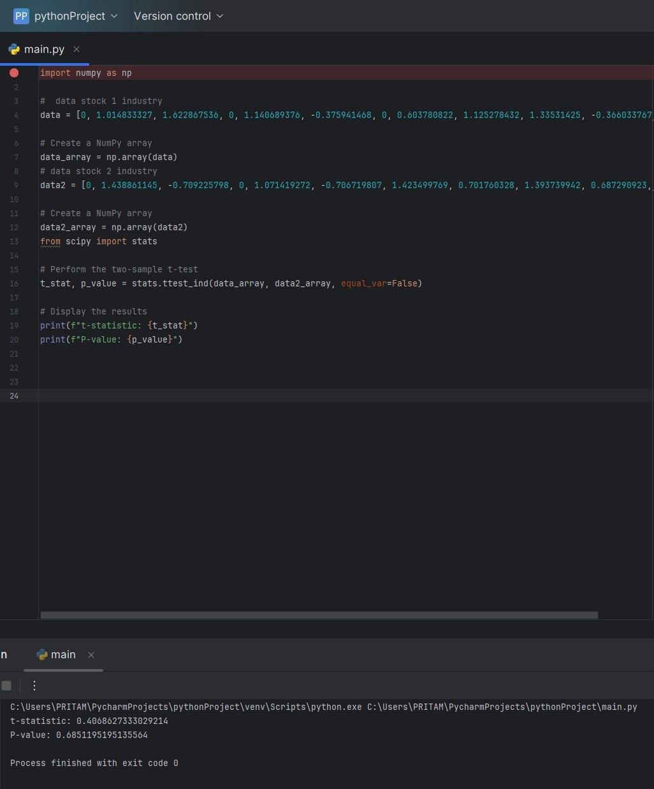

Figure 6

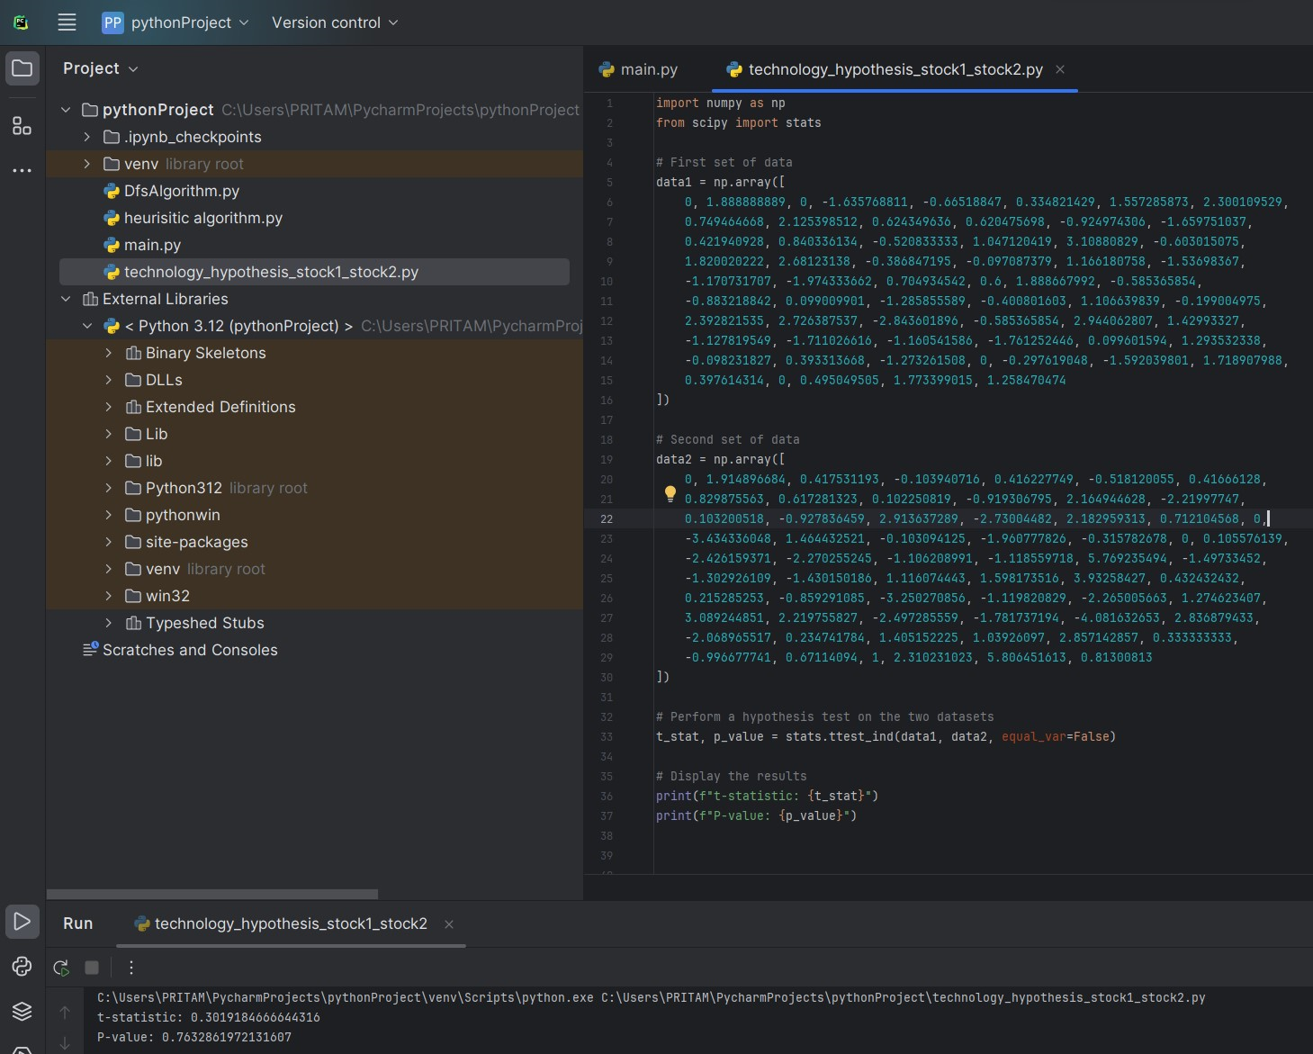

Figure 7

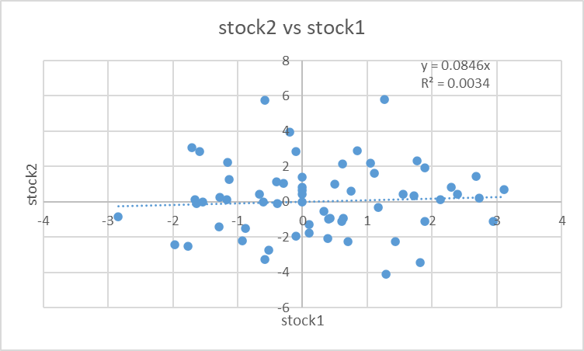

Figure 8

